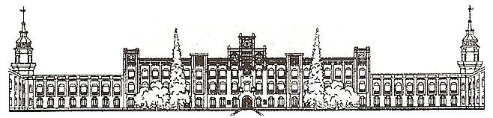

Міністерство освіти і науки України

Національний технічний університет України

«Київський політехнічний інститут»

***Лабораторна робота №2***

***з дисципліни «ОСНОВИ ПРОЕКТУВАННЯ ТРАНСЛЯТОРІВ»***

**«РОЗРОБКА ГЕНЕРАТОРА КОДУ»**

Виконав студент групи: КВ-11

ПІБ: Терентьєв Іван Дмитрович

Перевірив: ______________________

**Київ 2024**

*Постановка задачі*

1. Розробити програму генератора коду (ГК) для підмножини мови програмування SIGNAL, заданої за варіантом.
2. Програма генератора коду має забезпечувати:

* читання дерева розбору та таблиць, створених синтаксичним аналізатором, що було розроблено в розрахунково-графічній роботі;
* виявлення семантичних помилок;
* генерацію коду та/або побудову внутрішніх таблиць для генерації коду.

1. Скомпонувати повний компілятор, що складається з розроблених раніше лексичного та синтаксичного аналізаторів і генератора коду, який забезпечує наступне:

* генерацію коду та/або побудову внутрішніх таблиць для генерації коду;
* формування лістингу вхідної програми з повідомленнями про лексичні, синтаксичні та семантичні помилки.

*Граматика за варіантом 21*

**<signal-program>** --> <program>

**<program>** --> PROGRAM <procedure-identifier> ; <block>.

**<block>** --> <declarations> BEGIN <statements-list> END

**<declarations>** --> <constant-declarations>

**<constant-declarations>** --> CONST <constantdeclarations-list> | <empty>

**<constant-declarations-list>** --> <constantdeclaration> <constant-declarations-list> | <empty>

**<constant-declaration>** --> <constant-identifier> = <constant>;

**<statements-list>** --> <statement> <statements-list> | <empty>

**<statement>** --> CASE <expression> OF <alternativeslist> ENDCASE ;

**<alternatives-list>** --> <alternative> <alternativeslist> |<empty>

**<alternative>** --> <expression> : /<statements-list>\

**<expression>** --> <summand> <summands-list> | - <summand> <summands-list>

**<summands-list>** --> <add-instruction> <summand> |<summands-list> | <empty>

**<add-instruction>** --> + | -

**<summand>** --> <variable-identifier> | <unsigned-integer>

**<constant>** --> <unsigned-integer>

**<variable-identifier>** --> <identifier>

**<constant-identifier>** --> <identifier>

**<procedure-identifier>** --> <identifier>

**<identifier>** --> <letter><string>

**<string>** --> <letter><string> | <digit><string> |<empty>

**<unsigned-integer>** --> <digit><digits-string>

**<digits-string>** --> <digit><digits-string> | <empty>

**<digit>** --> 0 | 1 | 2 | 3 | 4 | 5 | 6 | 7 | 8 | 9

**<letter>** --> A | B | C | D | ... | Z

*Лістинг програми*

==> main.c <==

#include "lexer.h"

#include "out.h"

#include "semant.h"

#include "verify.h"

int main(int argc, char *argv[]) {

  proc_cli(argc, argv);

  if (gotError) {

    print_errors();

    return -1;

  } else

    proc_lexer(params._input_file);

  if (params.out_lexer) {

    if (params.verbose) {

      out_file_lexer();

      print_file_out();

    } else

      out_file_lexer();

  }

  if (gotError) {

    print_errors();

    return -1;

  } else {

    just_clean();

    proc_syntax();

  }

  if (params.out_syntax) {

    if (params.verbose) {

      out_file_syntax();

      print_file_out();

    } else

      out_file_syntax();

  }

  if (gotError)

  {

    print_errors();

    return -1;

  } else{

    just_clean();

    proc_semant();

  }

  if (params.out_codegen)

  {

    if(params.verbose)

    {

      out_file_codegen();

      print_file_out();

    } else

      out_file_codegen();

  }

  free_trees();

  free_errors();

  free_tables();

  free_tokens();

  if (params._verify_file != NULL) {

    verify(params._output_file, params._verify_file);

  }

  return 0;

}

==> lexer_state/constant.h <==

#include <stdbool.h>

#include <stddef.h>

#include "token_structure.h"

#ifndef CONSTANT_H

#define CONSTANT_H

typedef struct token Constant;

extern Constant *_constants;

extern size_t constantCount;

void add_to_constants(Constant constant);

bool is_constant(size_t tokenCode);

#endif

==> lexer_state/id_generator.h <==

#include <stddef.h>

#include <stdlib.h>

#ifndef ID_GENERATOR_H

#define ID_GENERATOR_H

size_t get_id(size_t row, size_t col, unsigned short int type);

#endif

==> lexer_state/identifier.h <==

#include "error.h"

#include "token_structure.h"

#ifndef IDENTIFIER_H

#define IDENTIFIER_H

typedef struct token Identifier;

extern Identifier *_identifiers;

extern size_t identifierCount;

void add_to_identifiers(Identifier identifier);

bool is_identifier(size_t tokenCode);

#endif

==> lexer_state/lexer.h <==

#ifndef LEXER_H

#define LEXER_H

#include "lexer_get.h"

// Main procedure of lexer

void proc_lexer(char *_input_file);

#endif

==> lexer_state/lexer_get.h <==

#include <stdio.h>

#include <stdlib.h>

#include "error.h"

#include "lexer_structure.h"

#include "token.h"

#ifndef LEXER_GET_H

#define LEXER_GET_H

void inp(FILE *__input_file);

void ws(FILE *__input_file);

void dig(FILE *__input_file);

void let(FILE *__input_file);

void dm1(FILE *__input_file);

void dm2(FILE *__input_file);

void com_begin(FILE *__input_file);

void com_confirm(FILE *__input_file, size_t row, size_t col);

void com_ending(FILE *__input_file, size_t row, size_t col);

void s_error(FILE *__input_file);

#endif

==> lexer_state/lexer_structure.h <==

#include <stdbool.h>

#include <stddef.h>

#ifndef LEXER_STRUCTURE_H

#define LEXER_STRUCTURE_H

struct lexer {

  char *_buffer;

  size_t bufferSize;

  size_t row;

  size_t col;

  char symbol;

  unsigned short int symbolType;

  bool inComment;

};

typedef struct lexer Lexer;

extern Lexer lexer;

void add_buffer_symbol();

void clean_buffer();

#endif

==> lexer_state/strings.h <==

#include <stdbool.h>

#include <stddef.h>

#include "token_structure.h"

#ifndef STRINGS_H

#define STRINGS_H

typedef struct token Stringy;

extern Stringy *_strings;

extern size_t stringsCount;

void add_to_strings(Stringy str);

bool is_stringy(size_t tokenCode);

#endif

==> lexer_state/symbol_type.h <==

#ifndef SYMBOL_TYPE_H

#define SYMBOL_TYPE_H

/*

@symbolType

*/

#define SYMBOL_START 0

#define SYMBOL_WS 1

#define SYMBOL_DIG 2

#define SYMBOL_LET 3

#define SYMBOL_DM1 4

#define SYMBOL_DM2 5

#define SYMBOL_COM_BEGIN 6

#define SYMBOL_COM_CONFIRM 7

#define SYMBOL_COM_ENDING 8

#define SYMBOL_ERROR 10 // 0xA Unknown symbol

#define SYMBOL_EOF 11   // 0xB End of file symbol

unsigned short int symbol_type(char symbol);

#endif

==> lexer_state/token.h <==

#include "error.h"

#include "token_structure.h"

#ifndef TOKEN_H

#define TOKEN_H

extern Token *_tokens;

extern size_t tokenCount;

void add_to_tokens(Token token);

#endif

==> lexer_state/token_structure.h <==

#include <stddef.h>

#include <stdlib.h>

#ifndef TOKEN_STRUCTURE_H

#define TOKEN_STRUCTURE_H

struct token {

  size_t row;

  size_t col;

  size_t code;

  char *_data;

  size_t dataSize;

};

typedef struct token Token;

Token create_token(size_t row, size_t col, char *_data, size_t dataSize,

                   unsigned short int type);

Token create_token_with_code(size_t row, size_t col, char *_data,

                             size_t dataSize, size_t code);

#endif

==> semant_state/semant.h <==

#include <stdlib.h>

#include "syntax.h"

#ifndef SEMANT_H

#define SEMANT_H

struct var{

    char* name;

    char* value;

};

typedef struct var Var;

struct cnst{

    char* name;

    char* value;

};

typedef struct cnst Const;

extern Const *consts;

extern size_t constCount;

extern Var *vars;

extern size_t varsCount;

extern char **statementsCode;

extern size_t codeCount;

extern char* program_name;

void proc_semant();

void generate_final_output();

bool iAmInConst(char *v);

bool iAmProgram(char *v);

bool iAmInVars(char *v);

void add_to_const(Const c);

void add_to_vars(Var v);

void add_to_statements(char *value);

char **add_to_semant_final_program(char *value);

extern size_t skip;

Tree *find_in_tree(Tree *cur_tree, char *value);

extern char **semant_final;

extern size_t semant_final_count;

#endif

==> syntax_state/knut_tables.h <==

#ifndef KNUT_TABLES_H

#define KNUT_TABLES_H

#include <stdbool.h>

#include <stdlib.h>

struct code {

  size_t addrTo;

  char *_term;

  bool isTerm;

};

typedef struct code Code;

struct line {

  size_t addr;

  Code code;

  bool atAddr;

  size_t afAddr;

};

typedef struct line Line;

struct table {

  size_t linesCount;

  Line *lines;

};

typedef struct table Table;

Table create_knut_table();

char *name_by_id(size_t addr);

#endif

==> syntax_state/syntax.h <==

#include "knut_tables.h"

#include "tree.h"

#ifndef SYNTAX_H

#define SYNTAX_H

extern Tree *_tree;

void proc_syntax();

struct probably {

  Tree *result;

  bool status;

};

typedef struct probably ProbablyResults;

ProbablyResults probe(Table table, size_t i);

Line ruler(Table table, size_t k);

#define rules(i) ruler(table, i)

#endif

==> syntax_state/terms.h <==

#ifndef TERMS_H

#define TERMS_H

#define SIGNAL_PROGRAM 0

#define SIGNAL_PROGRAM_FINISH 2

#define PROGRAM 3

#define PROGRAM_ENDING 7

#define BLOCK 8

#define DECLARATIONS 12

#define CONSTANT_DECLARATIONS 13

#define CONSTANT_DECLARATIONS_LIST 16

#define CONSTANT_DECLARATION 19

#define STATEMENTS_LIST 23

#define STATEMENT 26

#define ALTERNATIVES_LIST 36

#define ALTERNATIVE 39

#define EXPRESSION 44

#define SUMMANDS_LIST 49

#define ADD_INSTRUCTION 55

#define SUMMAND 57

#define CONSTANT 59

#define VARIABLE_IDENTIFIER 60

#define CONSTANT_IDENTIFIER 61

#define PROCEDURE_IDENTIFIER 62

#define ERROR 666

#define OK 777

/*

<identifier> --> <letter><string>                                  id>1000

<string> --> <letter><string> | <digit><string> | <empty>          id>750

<unsigned-integer> --> <digit><digits-string>                      id>500

<digits-string> --> <digit><digits-string> | <empty>

<digit> --> 0 | 1 | 2 | 3 | 4 | 5 | 6 | 7 | 8 | 9

<letter> --> A | B | C | D | ... | Z

*/

#define IDENTIFIER 100

#define UNSIGNED_INTEGER 101

#define STRING 102

#define EMPTY 200

#endif

==> syntax_state/tree.h <==

#include <stdlib.h>

#ifndef TREE_BUILDER_H

#define TREE_BUILDER_H

struct tree {

  char *_value;

  struct tree **_branches;

  size_t branchesCount;

  size_t id;

};

typedef struct tree Tree;

Tree *create_node(char *_value, size_t id);

void add_branch(Tree *_origin, Tree *_tree);

void free_tree(Tree *_tree);

/* add_branch defines*/

#define add_branch_with_token(token)                                           \

  do {                                                                         \

    add_branch(newTree, token);                                                \

    state = true;                                                              \

  } while (0)

#define add_branch_def_token()                                                 \

  add_branch_with_token(create_node(_tokens[tokenIterator]._data, i))

#define add_branch_empty() add_branch_with_token(create_node("<empty>", i))

#endif

==> util/cli.h <==

#ifndef CLI_H

#define CLI_H

#include "error.h"

struct params {

  char *_input_file;

  char *_output_file;

  bool verbose;

  bool out_lexer;

  bool out_syntax;

  bool out_codegen;

  char *_verify_file;

};

typedef struct params Params;

extern Params params;

void proc_cli(int argc, char *argv[]);

#endif

==> util/error.h <==

#include <stdbool.h>

#include <stddef.h>

#include <stdlib.h>

#ifndef ERROR_H

#define ERROR_H

struct error {

  size_t number;

  unsigned short int state;

  char *_error_message;

  bool critical;

  bool hasLineColumn;

  size_t row;

  size_t col;

  char *_expected;

  char *_here;

  bool syntaxer;

};

typedef struct error Error;

/*

@state

*/

#define NOT_ERROR 0

#define FILE_ACCESS 1

#define MEMORY_ACCESS 2

#define LEXER_STATE 3

#define SYNTAX_STATE 4

#define SEMANT_STATE 5

extern Error *_errors;

extern size_t errorCount;

extern bool gotError;

extern bool gotWarning;

Error create_error_syntaxer(size_t row, size_t col, char *_expected,

                            char *_here);

Error create_error_without_linecolumn(unsigned short int state,

                                      char *_error_message, bool critical);

Error create_error_with_linecolumn(unsigned short int state,

                                   char *_error_message, bool critical,

                                   size_t row, size_t col);

Error create_error_def();

void add_to_errors(Error error);

bool has_critical();

void clean_errors();

#endif

==> util/out.h <==

#include "cli.h"

#include "error.h"

#include "token_structure.h"

#ifndef OUT_H

#define OUT_H

void print_params();

void print_error(Error error);

void print_errors();

void print_lexer();

void print_token(Token token);

void print_tokens();

void out_file_lexer();

void print_file_out();

void out_file_errors();

void out_file_syntax();

void out_file_codegen();

void just_clean();

void free_trees();

void free_errors();

void free_tokens();

void free_tables();

#endif

==> util/verify.h <==

#ifndef VERIFY_H

#define VERIFY_H

void verify(char *_output, char *_verify);

#endif

==> lexer_state/constant.c <==

#include <stdbool.h>

#include "constant.h"

#include "error.h"

#include "token_structure.h"

Constant *_constants = NULL;

size_t constantCount = 0;

void add_to_constants(Constant constant) {

  constantCount++;

  _constants = (Token *)realloc(_constants, constantCount * sizeof(Token));

  if (_constants == NULL)

    add_to_errors(create_error_with_linecolumn(

        MEMORY_ACCESS, "Cannot reallocate *_constants", true, constant.row,

        constant.col));

  else

    _constants[constantCount - 1] = constant;

}

bool is_constant(size_t tokenCode) {

  for (size_t i = 0; i < constantCount; i++)

    if (tokenCode == _constants[i].code)

      return true;

  return false;

}

==> lexer_state/id_generator.c <==

#include <stdbool.h>

#include <string.h>

#include "constant.h"

#include "id_generator.h"

#include "identifier.h"

#include "lexer_structure.h"

#include "strings.h"

#include "symbol_type.h"

size_t get_keyword_id() {

  char *_verify[10] = {"PROGRAM", "VAR", "BEGIN",   "END",     "CONST",

                       "CASE",    "OF",  "ENDCASE", "INTEGER", "FLOAT"};

  for (size_t i = 0; i < 10; i++)

    if (!strcmp(lexer._buffer, _verify[i]))

      return i + 1;

  return 0;

}

size_t get_dm1_id() {

  char _verify[12] = {'+', '-', ':', '<', '>',  '=',

                      '.', ';', '[', ']', '\\', '/'};

  for (unsigned short i = 0; i < 12; i++)

    if (lexer._buffer[0] == _verify[i])

      return (size_t)lexer._buffer[0];

  return 0;

}

size_t get_dm2_id() {

  char _verify[3] = {'<', '>', ':'};

  if (strlen(lexer._buffer) > 1)

    if (lexer._buffer[1] == '=')

      for (size_t i = 0; i < 3; i++)

        if (lexer._buffer[0] == _verify[i])

          return i + 301;

  return get_dm1_id();

}

size_t get_id(size_t row, size_t col, unsigned short int type) {

  size_t base = 0;

  switch (type) {

  case SYMBOL_DIG:

    base = 501;

    for (size_t i = 0; i < constantCount; i++)

      if (!strcmp(lexer._buffer, _constants[i]._data))

        return _constants[i].code;

    base += constantCount;

    add_to_constants(create_token_with_code(row, col, lexer._buffer,

                                            lexer.bufferSize, base));

    break;

  case SYMBOL_LET:

    if (get_keyword_id()) {

      base = 400;

      base += get_keyword_id();

    } else {

      if (lexer._buffer[0] > 64 && lexer._buffer[0] < 91) {

        base = 1001;

        for (size_t i = 0; i < identifierCount; i++)

          if (!strcmp(lexer._buffer, _identifiers[i]._data))

            return _identifiers[i].code;

        base += identifierCount;

        add_to_identifiers(create_token_with_code(row, col, lexer._buffer,

                                                  lexer.bufferSize, base));

      } else {

        base = 750;

        for (size_t i = 0; i < stringsCount; i++)

          if (!strcmp(lexer._buffer, _strings[i]._data))

            return _strings[i].code;

        base += stringsCount;

        add_to_strings(create_token_with_code(row, col, lexer._buffer,

                                              lexer.bufferSize, base));

      }

    }

    break;

  case SYMBOL_DM1:

    base = get_dm1_id();

    break;

  case SYMBOL_DM2:

    base = get_dm2_id();

    break;

  default:

    add_to_errors(create_error_without_linecolumn(

        LEXER_STATE, "Impossible for get_code()", true));

    return 0;

  };

  return base;

}

==> lexer_state/identifier.c <==

#include <stdbool.h>

#include "identifier.h"

#include "token_structure.h"

Identifier *_identifiers = NULL;

size_t identifierCount = 0;

void add_to_identifiers(Identifier identifier) {

  identifierCount++;

  _identifiers =

      (Token *)realloc(_identifiers, identifierCount * sizeof(Identifier));

  if (_identifiers == NULL)

    add_to_errors(create_error_with_linecolumn(

        MEMORY_ACCESS, "Cannot reallocate *_identifiers", true, identifier.row,

        identifier.col));

  else

    _identifiers[identifierCount - 1] = identifier;

}

bool is_identifier(size_t tokenCode) {

  for (size_t i = 0; i < identifierCount; i++)

    if (tokenCode == _identifiers[i].code)

      return true;

  return false;

}

==> lexer_state/lexer.c <==

#include "lexer.h"

#include "stdlib.h"

#include "symbol_type.h"

Lexer lexer = {NULL, 0, 1, 1, '\0', SYMBOL_START, false};

void proc_lexer(char *_input_file) {

  FILE *__input_file;

  __input_file = fopen(_input_file, "r");

  if (__input_file == NULL)

    add_to_errors(create_error_without_linecolumn(

        FILE_ACCESS, "Cannot open input file.", true));

  else {

    inp(__input_file);

    do {

      switch (lexer.symbolType) {

      case SYMBOL_WS:

        ws(__input_file);

        break;

      case SYMBOL_DIG:

        dig(__input_file);

        break;

      case SYMBOL_LET:

        let(__input_file);

        break;

      case SYMBOL_DM1:

        dm1(__input_file);

        break;

      case SYMBOL_DM2:

        dm2(__input_file);

        break;

      case SYMBOL_COM_BEGIN:

        com_begin(__input_file);

        break;

      case SYMBOL_ERROR:

        s_error(__input_file);

        break;

      case SYMBOL_EOF:

        break;

      default:

        add_to_errors(create_error_without_linecolumn(

            LEXER_STATE, "Impossible if rrly, unknown category", true));

        lexer.symbolType = SYMBOL_EOF;

        break;

      };

    } while (lexer.symbolType != SYMBOL_EOF);

  }

  fclose(__input_file);

}

==> lexer_state/lexer_get.c <==

#include "lexer_get.h"

#include "symbol_type.h"

void inp(FILE *__input_file) {

  lexer.symbol = (char)fgetc(__input_file);

  if (lexer.symbol == '\n') {

    lexer.row++;

    lexer.col = 1;

  } else {

    if (lexer.symbol == '\t')

      lexer.col += 4;

    else

      lexer.col++;

  }

  lexer.symbolType = symbol_type(lexer.symbol);

}

void ws(FILE *__input_file) {

  do

    inp(__input_file);

  while (lexer.symbolType == SYMBOL_WS);

}

void dig(FILE *__input_file) {

  size_t row = lexer.row;

  size_t col = lexer.col;

  do {

    add_buffer_symbol();

    inp(__input_file);

  } while (lexer.symbolType == SYMBOL_DIG);

  add_to_tokens(

      create_token(row, col, lexer._buffer, lexer.bufferSize, SYMBOL_DIG));

  clean_buffer();

}

void let(FILE *__input_file) {

  size_t row = lexer.row;

  size_t col = lexer.col;

  do {

    add_buffer_symbol();

    inp(__input_file);

  } while (lexer.symbolType == SYMBOL_DIG || lexer.symbolType == SYMBOL_LET);

  add_to_tokens(

      create_token(row, col, lexer._buffer, lexer.bufferSize, SYMBOL_LET));

  clean_buffer();

}

void dm1(FILE *__input_file) {

  size_t row = lexer.row;

  size_t col = lexer.col;

  add_buffer_symbol();

  add_to_tokens(

      create_token(row, col, lexer._buffer, lexer.bufferSize, SYMBOL_DM1));

  clean_buffer();

  inp(__input_file);

}

void dm2(FILE *__input_file) {

  size_t row = lexer.row;

  size_t col = lexer.col;

  add_buffer_symbol();

  inp(__input_file);

  if (lexer.symbolType == SYMBOL_DM1) {

    add_buffer_symbol();

    inp(__input_file);

  }

  add_to_tokens(

      create_token(row, col, lexer._buffer, lexer.bufferSize, SYMBOL_DM2));

  clean_buffer();

}

void com_begin(FILE *__input_file) {

  size_t row = lexer.row;

  size_t col = lexer.col;

  inp(__input_file);

  if (lexer.symbol == '*') {

    lexer.inComment = true;

    com_confirm(__input_file, row, col);

  } else {

    add_to_errors(create_error_with_linecolumn(LEXER_STATE, "No * after (",

                                               true, row, col));

    inp(__input_file);

  }

}

void com_confirm(FILE *__input_file, size_t row, size_t col) {

  inp(__input_file);

  if (lexer.symbol == '*') {

    com_ending(__input_file, row, col);

  } else {

    if (lexer.symbolType == 7) {

      add_to_errors(create_error_with_linecolumn(

          LEXER_STATE, "Not closed comment", true, row, col));

      inp(__input_file);

    } else

      com_confirm(__input_file, row, col);

  }

}

void com_ending(FILE *__input_file, size_t row, size_t col) {

  inp(__input_file);

  if (lexer.symbol == ')') {

    inp(__input_file);

    lexer.inComment = false;

  } else {

    if (lexer.symbol == '*')

      com_ending(__input_file, row, col);

    else {

      if (lexer.symbolType == 7) {

        add_to_errors(create_error_with_linecolumn(

            LEXER_STATE, "Not closed comment", true, row, col));

        inp(__input_file);

      } else

        com_confirm(__input_file, row, col);

    }

  }

}

void s_error(FILE *__input_file) {

  if (lexer.symbolType == SYMBOL_COM_CONFIRM ||

      lexer.symbolType == SYMBOL_COM_ENDING)

    add_to_errors(create_error_with_linecolumn(

        LEXER_STATE, "Comment is not openned or already closed", false,

        lexer.row, lexer.col));

  else

    add_to_errors(create_error_with_linecolumn(LEXER_STATE, "Got error symbol",

                                               true, lexer.row, lexer.col));

  inp(__input_file);

}

==> lexer_state/lexer_structure.c <==

#include <stdlib.h>

#include "error.h"

#include "lexer_structure.h"

void add_buffer_symbol() {

  lexer._buffer =

      (char *)realloc(lexer._buffer, (lexer.bufferSize + 2) * sizeof(char));

  if (lexer._buffer == NULL)

    add_to_errors(create_error_with_linecolumn(

        LEXER_STATE, "Cannot resize *buff", true, lexer.row, lexer.col));

  lexer._buffer[lexer.bufferSize] = lexer.symbol;

  lexer._buffer[lexer.bufferSize + 1] = '\0';

  lexer.bufferSize++;

}

void clean_buffer() {

  lexer._buffer = NULL;

  lexer.bufferSize = 0;

}

==> lexer_state/strings.c <==

#include <stdbool.h>

#include "error.h"

#include "strings.h"

#include "token_structure.h"

Stringy *_strings = NULL;

size_t stringsCount = 0;

void add_to_strings(Stringy str) {

  stringsCount++;

  _strings = (Token *)realloc(_strings, stringsCount * sizeof(Stringy));

  if (_strings == NULL)

    add_to_errors(create_error_with_linecolumn(

        MEMORY_ACCESS, "Cannot reallocate *_strings", true, str.row, str.col));

  else

    _strings[stringsCount - 1] = str;

}

bool is_stringy(size_t tokenCode) {

  for (size_t i = 0; i < stringsCount; i++)

    if (tokenCode == _strings[i].code)

      return true;

  return false;

}

==> lexer_state/symbol_type.c <==

#include "symbol_type.h"

#include <stdio.h>

unsigned short int symbol_type(char symbol) {

  unsigned short int category = 6;

  if ((symbol > 7 && symbol < 14) || symbol == 32)

    category = SYMBOL_WS;

  else if (symbol > 47 && symbol < 58)

    category = SYMBOL_DIG;

  else if (symbol > 64 && symbol < 91)

    category = SYMBOL_LET;

  else if (symbol == '.' || symbol == ';' || symbol == '[' || symbol == ']' ||

           symbol == '=' || symbol == '+' || symbol == '-')

    category = SYMBOL_DM1;

  else if (symbol == ':' || symbol == '<' || symbol == '>' || symbol == '/' ||

           symbol == '\\')

    category = SYMBOL_DM2;

  else if (symbol == '(')

    category = SYMBOL_COM_BEGIN;

  else if (symbol == EOF)

    category = SYMBOL_EOF;

  else

    category = SYMBOL_ERROR;

  return category;

}

==> lexer_state/token.c <==

#include "token.h"

#include "id_generator.h"

Token *_tokens = NULL;

size_t tokenCount = 0;

void add_to_tokens(Token token) {

  tokenCount++;

  _tokens = (Token *)realloc(_tokens, tokenCount * sizeof(Token));

  if (_tokens == NULL)

    add_to_errors(create_error_with_linecolumn(MEMORY_ACCESS,

                                               "Cannot reallocate *_tokens",

                                               true, token.row, token.col));

  else

    _tokens[tokenCount - 1] = token;

}

==> lexer_state/token_structure.c <==

#include "token_structure.h"

#include "id_generator.h"

Token create_token(size_t row, size_t col, char *_data, size_t dataSize,

                   unsigned short int type) {

  size_t code = get_id(row, col, type);

  Token token = {row, col, code, _data, dataSize};

  return token;

}

Token create_token_with_code(size_t row, size_t col, char *_data,

                             size_t dataSize, size_t code) {

  Token token = {row, col, code, _data, dataSize};

  return token;

}

==> semant_state/add_to.c <==

#include "error.h"

#include "semant.h"

#include <stdio.h>

#include <string.h>

void add_to_const(Const c) {

  if (!iAmInConst(c.name) && !iAmProgram(c.name)) {

    constCount++;

    consts = (Const *)realloc(consts, sizeof(Const) * constCount);

    if (consts == NULL)

      add_to_errors(create_error_without_linecolumn(

          MEMORY_ACCESS, "Cannot realloc consts", true));

    else {

      consts[constCount - 1] = c;

    }

  } else {

    char val[100];

    snprintf(val, 100, "Cannot create const %s, name used by CONST or PROGRAM",

             c.name);

    add_to_errors(create_error_without_linecolumn(SEMANT_STATE, val, true));

  }

}

void add_to_vars(Var v) {

  if (!iAmInConst(v.name) && !iAmProgram(v.name)) {

    varsCount++;

    vars = (Var *)realloc(vars, sizeof(Var) * varsCount);

    if (vars == NULL)

      add_to_errors(create_error_without_linecolumn(

          MEMORY_ACCESS, "Cannot realloc vars", true));

    else

      vars[varsCount - 1] = v;

  } else {

    char val[100];

    snprintf(val, 100, "Cannot create var %s, name used by CONST or PROGRAM",

             v.name);

    add_to_errors(create_error_without_linecolumn(SEMANT_STATE, val, true));

  }

}

void add_to_statements(char *value) {

  codeCount++;

  statementsCode = (char **)realloc(statementsCode, sizeof(value) * codeCount);

  if (statementsCode == NULL)

    add_to_errors(create_error_without_linecolumn(

        MEMORY_ACCESS, "Cannot realloc statementsCode", true));

  else {

    statementsCode[codeCount - 1] = malloc(sizeof(char) * strlen(value));

    strcpy(statementsCode[codeCount - 1], value);

  }

}

char **add_to_semant_final_program(char *value) {

  semant_final_count++;

  semant_final =

      (char **)realloc(semant_final, sizeof(value) * semant_final_count);

  if (semant_final == NULL)

    add_to_errors(create_error_without_linecolumn(

        MEMORY_ACCESS, "Cannot realloc semant_final", true));

  else {

    semant_final[semant_final_count - 1] = malloc(sizeof(char) * strlen(value));

    strcpy(semant_final[semant_final_count - 1], value);

  }

  return semant_final;

}

==> semant_state/generate_final.c <==

#include "semant.h"

#include <stdio.h>

void generate_final_output()

{

  char v[100];

  snprintf(v, 100, ".section .rodata");

  add_to_semant_final_program(v);

  for (size_t i = 0; i < constCount; i++) {

    snprintf(v, 100, "\t%s:\t.quad %s", consts[i].name, consts[i].value);

    add_to_semant_final_program(v);

  }

  snprintf(v, 100, "\n");

  add_to_semant_final_program(v);

  snprintf(v, 100, ".section .bbs");

  add_to_semant_final_program(v);

  for (size_t i = 0; i < varsCount; i++) {

    snprintf(v, 100, "\t%s:\t.space %s", vars[i].name, vars[i].value);

    add_to_semant_final_program(v);

  }

  snprintf(v, 100, "\n");

  add_to_semant_final_program(v);

  snprintf(v, 100, ".section .text");

  add_to_semant_final_program(v);

  snprintf(v, 100, ".globl main");

  add_to_semant_final_program(v);

  snprintf(v, 100, "main:");

  add_to_semant_final_program(v);

  snprintf(v, 100, "\tjmp %s", program_name);

  add_to_semant_final_program(v);

  snprintf(v, 100, "%s:", program_name);

  add_to_semant_final_program(v);

  for (size_t i = 0; i < codeCount; i++)

    add_to_semant_final_program(statementsCode[i]);

  snprintf(v, 100, "\tmovq\t$60, %%rax");

  add_to_semant_final_program(v);

  snprintf(v, 100, "\txor\t%%rdi, %%rdi");

  add_to_semant_final_program(v);

  snprintf(v, 100, "\tsyscall");

  add_to_semant_final_program(v);

}

==> semant_state/iAm.c <==

#include "semant.h"

#include <string.h>

bool iAmInConst(char *v) {

  for (size_t i = 0; i < constCount; i++) {

    if (strcmp(consts[i].name, v) == 0)

      return true;

  }

  return false;

}

bool iAmProgram(char *v)

{

  if(strcmp(program_name,v) == 0)

    return true;

  return false;

}

bool iAmInVars(char *v) {

  for (size_t i = 0; i < varsCount; i++) {

    if (strcmp(vars[i].name, v) == 0)

      return true;

  }

  return false;

}

==> semant_state/semant.c <==

#include "semant.h"

#include "error.h"

#include <stdio.h>

#include <string.h>

char **semant_final = NULL;

size_t semant_final_count = 0;

char *program_name = NULL;

Const *consts = NULL;

size_t constCount = 0;

Var *vars = NULL;

size_t varsCount = 0;

char **statementsCode = NULL;

size_t codeCount = 0;

size_t skip = 0;

size_t labelCounter = 0;

size_t dived = 1;

#define macro_bbb(val, x, y, z) val->_branches[x]->_branches[y]->_branches[z]

#define macro_bbbb(val, x, y, z, k)                                            \

  val->_branches[x]->_branches[y]->_branches[z]->_branches[k]

void process_summands_list(Tree *list, char *reg) {

  char v[100];

  char err[200];

  if (strcmp(list->_branches[0]->_value, "<empty>") == 0) {

  } else {

    if (strcmp(list->_branches[0]->_value, "+") == 0) {

      if (strcmp(macro_bbb(list, 1, 0, 0)->_value, "<identifier>") == 0) {

        snprintf(v, 100, "\taddq\t%s, %%%s",

                 macro_bbbb(list, 1, 0, 0, 0)->_value, reg);

        if (!iAmInVars(macro_bbbb(list, 1, 0, 0, 0)->_value)) {

          snprintf(err, 200, "Variable %s used before declaration",

                   macro_bbbb(list, 1, 0, 0, 0)->_value);

          add_to_errors(

              create_error_without_linecolumn(SEMANT_STATE, err, true));

        }

      } else

        snprintf(v, 100, "\taddq\t%s, %%%s", macro_bbb(list, 1, 0, 0)->_value,

                 reg);

    } else {

      if (strcmp(macro_bbb(list, 1, 0, 0)->_value, "<identifier>") == 0) {

        snprintf(v, 100, "\tsubq\t%s, %%%s",

                 macro_bbbb(list, 1, 0, 0, 0)->_value, reg);

        if (!iAmInVars(macro_bbbb(list, 1, 0, 0, 0)->_value)) {

          snprintf(err, 200, "Variable %s used before declaration",

                   macro_bbbb(list, 1, 0, 0, 0)->_value);

          add_to_errors(

              create_error_without_linecolumn(SEMANT_STATE, err, true));

        }

      } else

        snprintf(v, 100, "\tsubq\t%s, %%%s", macro_bbb(list, 1, 0, 0)->_value,

                 reg);

    }

    add_to_statements(v);

    if (list->branchesCount == 3) {

      process_summands_list(list->_branches[2], reg);

    }

  }

}

void process_expression(Tree *expression, char *reg) {

  char v[100];

  char err[200];

  if (strcmp(expression->_branches[0]->_value, "<summand>") == 0) {

    if (strcmp(macro_bbb(expression, 0, 0, 0)->_value, "<identifier>") == 0) {

      snprintf(v, 100, "\tmovq\t%s, %%%s",

               macro_bbbb(expression, 0, 0, 0, 0)->_value, reg);

      if (!iAmInVars(macro_bbbb(expression, 0, 0, 0, 0)->_value)) {

        snprintf(err, 200, "Variable %s used before declaration",

                 macro_bbbb(expression, 0, 0, 0, 0)->_value);

        add_to_errors(create_error_without_linecolumn(SEMANT_STATE, err, true));

      }

    } else

      snprintf(v, 100, "\tmovq\t%s, %%%s",

               macro_bbb(expression, 0, 0, 0)->_value, reg);

    add_to_statements(v);

    process_summands_list(expression->_branches[1], reg);

  } else {

    snprintf(v, 100, "\tmovq\t$0, %%%s", reg);

    add_to_statements(v);

    if (strcmp(macro_bbb(expression, 0, 1, 0)->_value, "<identifier>") == 0) {

      snprintf(v, 100, "\tmovq\t%s, %%%s",

               macro_bbbb(expression, 0, 1, 0, 0)->_value, reg);

      if (!iAmInVars(macro_bbbb(expression, 0, 1, 0, 0)->_value)) {

        snprintf(err, 200, "Variable %s used before declaration",

                 macro_bbbb(expression, 0, 1, 0, 0)->_value);

        add_to_errors(create_error_without_linecolumn(SEMANT_STATE, err, true));

      }

    } else

      snprintf(v, 100, "\tmovq\t%s, %%%s",

               macro_bbb(expression, 0, 1, 0)->_value, reg);

    process_summands_list(expression->_branches[2], reg);

  }

}

void process_statement(Tree *stats) {

  Var v;

  v.name = macro_bbb(stats, 0, 0, 0)->_value;

  v.value = "8";

  process_expression(stats->_branches[2], "rax");

  add_to_vars(v);

  char val[100];

  snprintf(val, 100, "\tmovq\t%%rax, %s", v.name);

  add_to_statements(val);

}

size_t labelCounterBackup = 0;

void dive_alternatives(Tree *my_tree, Tree *parent, char *val) {

  if (strcmp(my_tree->_value, "<expression>") == 0) {

    if (parent != NULL) {

      if (strcmp(parent->_value, val) == 0 &&

          strcmp("<alternative>", val) == 0) {

        process_expression(my_tree, "rbx");

        char v[100];

        snprintf(v, 100, "\tcmpq\t%%rax, %%rbx");

        add_to_statements(v);

        snprintf(v, 100, "\tje\t?L%llu", labelCounter++);

        add_to_statements(v);

      } else if (strcmp(parent->_value, val) == 0 &&

                 strcmp("<statement>", val) == 0 && dived == 0) {

        char v[100];

        snprintf(v, 100, "?L%llu: NOP", labelCounter++);

        add_to_statements(v);

        process_statement(parent);

        snprintf(v, 100, "\tjmp\t?L%llu", labelCounterBackup);

        add_to_statements(v);

      } else if (strcmp(parent->_value, val) == 0 &&

                 strcmp("<statement>", val) == 0) {

        dived--;

      }

    }

  } else {

    for (size_t i = 0; i < my_tree->branchesCount; i++) {

      dive_alternatives(my_tree->_branches[i], my_tree, val);

    }

  }

}

void proc_name() {

  Tree *name = find_in_tree(_tree, "<procedure-identifier>");

  program_name = name->_branches[0]->_branches[0]->_value;

}

void proc_const(Tree *cur_tree) {

  Tree *constDeclars = find_in_tree(cur_tree, "<constant-declarations-list>");

  if (constDeclars != NULL) {

    Const c;

    c.name = macro_bbbb(constDeclars, 0, 0, 0, 0)->_value;

    c.value = macro_bbbb(constDeclars, 0, 2, 0, 0)->_value;

    add_to_const(c);

    proc_const(constDeclars->_branches[1]);

  }

}

void proc_statements(Tree *cur_tree) {

  Tree *statementDeclars = find_in_tree(cur_tree, "<statements-list>");

  if (statementDeclars != NULL) {

    if (strcmp(statementDeclars->_branches[0]->_branches[0]->_value, "CASE") ==

        0) {

      char v[100];

      process_expression(statementDeclars->_branches[0]->_branches[1], "rax");

      dive_alternatives(statementDeclars->_branches[0], NULL, "<alternative>");

      labelCounterBackup = labelCounter;

      snprintf(v, 100, "\tjmp\t?L%llu", labelCounter++);

      add_to_statements(v);

      labelCounter = 0;

      dive_alternatives(statementDeclars->_branches[0], NULL, "<statement>");

      labelCounter = labelCounterBackup;

      snprintf(v, 100, "?L%llu: NOP", labelCounter++);

      add_to_statements(v);

    } else if (strcmp(statementDeclars->_branches[0]->_branches[0]->_value,

                      "<variable-identifier>") == 0) {

      process_statement(statementDeclars->_branches[0]);

    } else {

      add_to_errors(create_error_without_linecolumn(

          SEMANT_STATE, "Impossible statement", true));

    }

    proc_statements(statementDeclars->_branches[1]);

  }

}

void proc_semant() {

  proc_name();

  proc_const(_tree);

  proc_statements(_tree);

  generate_final_output();

}

==> semant_state/tree_finder.c <==

#include "semant.h"

#include <string.h>

Tree *find_in_tree(Tree *cur_tree, char *value) {

  if (strcmp(cur_tree->_value, value) == 0 && skip == 0) {

    return cur_tree;

  } else {

    if (strcmp(cur_tree->_value, value) == 0)

      skip--;

    if (cur_tree->branchesCount != 0) {

      for (size_t i = 0; i < cur_tree->branchesCount; i++) {

        Tree *temp = find_in_tree(cur_tree->_branches[i], value);

        if (temp != NULL) {

          return temp;

        }

      }

      return NULL;

    } else

      return NULL;

  }

}

==> syntax_state/knut_tables.c <==

#include "knut_tables.h"

#include "error.h"

#include "terms.h"

Code new_code(size_t addrTo, char *_term) {

  Code myCode = {addrTo, _term, false};

  if (_term != NULL)

    myCode.isTerm = true;

  return myCode;

}

Line new_line(size_t addr, Code myCode, bool at, size_t afAddr) {

  Line myLine = {addr, myCode, at, afAddr};

  return myLine;

}

void insert(Table *_table, Line myLine) {

  _table->linesCount++;

  _table->lines =

      (Line *)realloc(_table->lines, _table->linesCount * sizeof(Line));

  if (_table->lines == NULL)

    add_to_errors(create_error_without_linecolumn(

        MEMORY_ACCESS, "Cannot reallocate *knut_lines", true));

  else

    _table->lines[_table->linesCount - 1] = myLine;

}

char *name_by_id(size_t addr) {

  switch (addr) {

  case SIGNAL_PROGRAM:

    return "<signal-program>";

  case PROGRAM:

    return "<program>";

  case BLOCK:

    return "<block>";

  case DECLARATIONS:

    return "<declarations>";

  case CONSTANT_DECLARATIONS:

    return "<constant-declarations>";

  case CONSTANT_DECLARATIONS_LIST:

    return "<constant-declarations-list>";

  case CONSTANT_DECLARATION:

    return "<constant-declaration>";

  case STATEMENT:

    return "<statement>";

  case STATEMENTS_LIST:

    return "<statements-list>";

  case ALTERNATIVES_LIST:

    return "<alternatives-list>";

  case ALTERNATIVE:

    return "<alternative>";

  case EXPRESSION:

    return "<expression>";

  case SUMMANDS_LIST:

    return "<summands-list>";

  case ADD_INSTRUCTION:

    return "<add-instruction>";

  case SUMMAND:

    return "<summand>";

  case CONSTANT:

    return "<constant>";

  case VARIABLE_IDENTIFIER:

    return "<variable-identifier>";

  case CONSTANT_IDENTIFIER:

    return "<constant-identifier>";

  case PROCEDURE_IDENTIFIER:

    return "<procedure-identifier>";

  case UNSIGNED_INTEGER:

    return "<unsigned-integer>";

  case IDENTIFIER:

    return "<identifier>";

  case STRING:

    return "<string>";

  case EMPTY:

    return "<empty>";

  default:

    return "<error>";

  };

}

/*

rule(addr,addr_to,term,at_addr,af_addr)

Creates new rule in knut table

*/

#define rule(addr, addr_to, term, at_addr, af_addr)                            \

  insert(&myTable, new_line(addr, new_code(addr_to, term), at_addr, af_addr))

Table create_knut_table() {

  Table myTable = {.linesCount = 0, .lines = NULL};

  /*

  AT - ACTION TRUE

  AF - ACTION FALSE

  */

  /*   ADDR ADDR_TO TERM AT AF_ADDR*/

  /*<signal-program> --> <program> */

  rule(0, SIGNAL_PROGRAM, NULL, false, ERROR);

  rule(1, PROGRAM, NULL, false, ERROR);

  rule(2, SIGNAL_PROGRAM_FINISH, NULL, true, ERROR);

  /*<program> --> PROGRAM <procedure-identifier> ; <block> .*/

  rule(3, 0, "PROGRAM", false, ERROR);

  rule(4, PROCEDURE_IDENTIFIER, NULL, false, ERROR);

  rule(5, 0, ";", false, ERROR);

  rule(6, BLOCK, NULL, false, ERROR);

  rule(7, 0, ".", true, ERROR);

  /*<block> --> <declarations> BEGIN <statements-list> END*/

  rule(8, DECLARATIONS, NULL, false, ERROR);

  rule(9, 0, "BEGIN", false, ERROR);

  rule(10, STATEMENTS_LIST, NULL, false, ERROR);

  rule(11, 0, "END", true, ERROR);

  /*<declarations> --> <constant-declarations>*/

  rule(12, CONSTANT_DECLARATIONS, NULL, true, ERROR);

  /*<constant-declarations> --> CONST <constant-declarations-list> | <empty>*/

  rule(13, 0, "CONST", false, ERROR);

  rule(14, CONSTANT_DECLARATIONS_LIST, NULL, true, 15);

  rule(15, EMPTY, NULL, true, ERROR);

  /*<constant-declarations-list> --> <constantdeclaration>

   * <constant-declarations-list> | <empty>*/

  rule(16, CONSTANT_DECLARATION, NULL, false, ERROR);

  rule(17, CONSTANT_DECLARATIONS_LIST, NULL, true, 18);

  rule(18, EMPTY, NULL, true, ERROR);

  /*<constant-declaration> --> <constant-identifier> = <constant>;*/

  rule(19, CONSTANT_IDENTIFIER, NULL, false, ERROR);

  rule(20, 0, "=", false, ERROR);

  rule(21, CONSTANT, NULL, false, ERROR);

  rule(22, 0, ";", true, ERROR);

  /*<statements-list> --> <statement> <statement-list> | <empty>*/

  rule(23, STATEMENT, NULL, false, ERROR);

  rule(24, STATEMENTS_LIST, NULL, true, 25);

  rule(25, EMPTY, NULL, true, ERROR);

  /*<statement> --> CASE <expression> OF <alternativeslist> ENDCASE ;|

  <variable-identifier> := <expression> ;*/

  rule(26, 0, "CASE", false, 32);

  rule(27, EXPRESSION, NULL, false, ERROR);

  rule(28, 0, "OF", false, ERROR);

  rule(29, ALTERNATIVES_LIST, NULL, false, ERROR);

  rule(30, 0, "ENDCASE", false, ERROR);

  rule(31, 0, ";", true, ERROR);

  rule(32, VARIABLE_IDENTIFIER, NULL, false, ERROR);

  rule(33, 0, ":=", false, ERROR);

  rule(34, EXPRESSION, NULL, false, ERROR);

  rule(35, 0, ";", true, ERROR);

  /*<alternatives-list> --> <alternative> <alternativeslist> | <empty>*/

  rule(36, ALTERNATIVE, NULL, false, ERROR);

  rule(37, ALTERNATIVES_LIST, NULL, true, 38);

  rule(38, EMPTY, NULL, true, ERROR);

  /*<alternative> --> <expression> : /<statements-list>\*/

  rule(39, EXPRESSION, NULL, false, ERROR);

  rule(40, 0, ":", false, ERROR);

  rule(41, 0, "/", false, ERROR);

  rule(42, STATEMENTS_LIST, NULL, false, ERROR);

  rule(43, 0, "\\", true, ERROR);

  /*<expression> --> <summand> <summands-list> | - <summand> <summands-list>*/

  rule(44, SUMMAND, NULL, false, 46);

  rule(45, SUMMANDS_LIST, NULL, true, ERROR);

  rule(46, 0, "-", false, ERROR);

  rule(47, SUMMAND, NULL, false, ERROR);

  rule(48, SUMMANDS_LIST, NULL, true, ERROR);

  /*<summands-list> --> <add-instruction> <summand> | <summands-list> |

   * <empty>*/

  rule(49, ADD_INSTRUCTION, NULL, false, 54);

  rule(50, SUMMAND, NULL, false, ERROR);

  rule(51, SUMMANDS_LIST, NULL, true, 52);

  rule(52, ADD_INSTRUCTION, NULL, false, 54);

  rule(53, SUMMAND, NULL, true, ERROR);

  rule(54, EMPTY, NULL, true, ERROR);

  /*<add-instruction> --> + | -*/

  rule(55, 0, "+", true, 56);

  rule(56, 0, "-", true, ERROR);

  /*<summand> --> <variable-identifier> | <unsigned-integer>*/

  rule(57, VARIABLE_IDENTIFIER, NULL, true, 58);

  rule(58, UNSIGNED_INTEGER, NULL, true, ERROR);

  /*<constant> --> <unsigned-integer>*/

  rule(59, UNSIGNED_INTEGER, NULL, true, ERROR);

  /*<variable-identifier> --> <identifier>*/

  rule(60, IDENTIFIER, NULL, true, ERROR);

  /*<constant-identifier> --> <identifier>*/

  rule(61, IDENTIFIER, NULL, true, ERROR);

  /*<procedure-identifier> --> <identifier>*/

  rule(62, IDENTIFIER, NULL, true, ERROR);

  rule(UNSIGNED_INTEGER, 0, "", true, ERROR);

  rule(IDENTIFIER, 0, "", true, ERROR);

  rule(STRING, 0, "", true, ERROR);

  rule(EMPTY, 0, "", true, ERROR);

  return myTable;

}

==> syntax_state/ruler.c <==

#include "syntax.h"

Line ruler(Table table, size_t k) {

  for (size_t i = 0; i < table.linesCount; i++)

    if (table.lines[i].addr == k)

      return table.lines[i];

  exit(EXIT_FAILURE);

}

==> syntax_state/syntax.c <==

#include <stdbool.h>

#include <stdio.h>

#include <string.h>

#include "constant.h"

#include "error.h"

#include "identifier.h"

#include "knut_tables.h"

#include "strings.h"

#include "syntax.h"

#include "terms.h"

#include "token.h"

Tree *_tree;

Tree *_backup;

size_t tokenIterator = 0;

char *_expected;

void proc_syntax() {

  Table table = create_knut_table();

  _tree = create_node(name_by_id(SIGNAL_PROGRAM), SIGNAL_PROGRAM);

  ProbablyResults run = probe(table, PROGRAM);

  if (run.status)

    add_branch(_tree, run.result);

  else {

    add_to_errors(create_error_syntaxer(

        _tokens[tokenIterator].row, _tokens[tokenIterator].col,

        run.result->_value, _tokens[run.result->id]._data));

    add_branch(_tree, _backup);

  }

}

ProbablyResults probe(Table table, size_t i) {

  ProbablyResults ret = {false, NULL};

  bool state = false;

  Tree *newTree = create_node(name_by_id(i), i);

  size_t savedTokenPos = tokenIterator;

  bool atNotFinished = true;

  do {

    if (!rules(i).code.isTerm) {

      ProbablyResults inner_probe = probe(table, rules(i).code.addrTo);

      if (inner_probe.status == true) {

        if (rules(i).atAddr != true)

          i++;

        else

          atNotFinished = false;

        add_branch(newTree, inner_probe.result);

        state = true;

      } else {

        if (rules(i).afAddr != ERROR) {

          i = rules(i).afAddr;

          state = true;

        } else {

          state = false;

          ret.result = inner_probe.result;

          ret.status = state;

          return ret;

        }

      }

    } else {

      state = false;

      switch (rules(i).addr) {

      case UNSIGNED_INTEGER:

        if (is_constant(_tokens[tokenIterator].code))

          add_branch_def_token();

        break;

      case IDENTIFIER:

        if (is_identifier(_tokens[tokenIterator].code))

          add_branch_def_token();

        break;

      case STRING:

        if (is_stringy(_tokens[tokenIterator].code))

          add_branch_def_token();

        break;

      case EMPTY:

        add_branch_empty();

        break;

      default:

        if (tokenIterator < tokenCount)

          if (strcmp(rules(i).code._term, _tokens[tokenIterator]._data) == 0)

            add_branch_def_token();

      };

      if (state == false) {

        if (rules(i).afAddr != ERROR) {

          i = rules(i).afAddr;

          state = true;

        } else if (rules(i).addr < 100) {

          ret.status = false;

          ret.result = create_node(rules(i).code._term, tokenIterator);

          _backup = newTree;

          tokenIterator = savedTokenPos;

          return ret;

        }

      } else {

        if (rules(i).addr != EMPTY)

          tokenIterator++;

        if (rules(i).addr < 100 && rules(i).atAddr != true)

          i++;

        else

          atNotFinished = false;

      }

    }

  } while (atNotFinished && state && errorCount < 1);

  ret.result = newTree;

  ret.status = state;

  return ret;

}

==> syntax_state/tree.c <==

#include "tree.h"

#include "error.h"

#include "symbol_type.h"

#include "token.h"

Tree *create_node(char *_value, size_t id) {

  Tree *t;

  t = (Tree *)malloc(sizeof(Tree));

  t->_branches = NULL;

  t->branchesCount = 0;

  t->_value = _value;

  t->id = id;

  return t;

}

void add_branch(Tree *_origin, Tree *_tree) {

  _origin->branchesCount++;

  _origin->_branches = (Tree **)realloc(

      _origin->_branches, _origin->branchesCount * sizeof(Tree *));

  if (_origin->_branches == NULL)

    add_to_errors(create_error_without_linecolumn(

        MEMORY_ACCESS, "Cannot reallocate *_branches", true));

  else

    _origin->_branches[_origin->branchesCount - 1] = _tree;

}

void free_tree(Tree *_tree) {

  if (_tree != 0) {

    for (size_t i = 0; i < _tree->branchesCount; i++)

      free(_tree->_branches[i]);

    if (_tree->branchesCount != 0)

      free(_tree->_branches);

    free(_tree);

  }

}

==> util/cli.c <==

#include <stdbool.h>

#include <stdio.h>

#include <stdlib.h>

#include <string.h>

#include <unistd.h>

#include "cli.h"

#include "error.h"

#define WIN

Params params = {NULL, "output", false, true, true, true, NULL};

void check_file_access(char *_file, bool inputFile) {

  if (access(_file, F_OK) == -1) {

    if (inputFile)

      add_to_errors(create_error_without_linecolumn(

          FILE_ACCESS, "Missing access to input/verify file", true));

    else

      add_to_errors(create_error_without_linecolumn(

          FILE_ACCESS, "File for output does not exist, creating...", false));

  }

}

void check_file_missing(char *_file) {

  FILE *_fp;

  if (_file != NULL) {

#ifdef WIN

    _fp = fopen(_file, "w+");

#endif

#ifndef WIN

    _fp = fopen(_file, "w");

#endif

    if (_fp == NULL)

      add_to_errors(create_error_without_linecolumn(

          FILE_ACCESS, "Cannot create/open output file", true));

    fclose(_fp);

  } else

    add_to_errors(create_error_without_linecolumn(

        FILE_ACCESS, "Cannot create/open output file", true));

}

void proc_cli(int argc, char *argv[]) {

  if (argc == 2)

    params._input_file = argv[1];

  else {

    for (int i = 1; i < argc; i++) {

      if (strcmp(argv[i], "-f") == 0 && i + 1 < argc)

        params._input_file = argv[++i];

      else if (strcmp(argv[i], "-o") == 0 && i + 1 < argc)

        params._output_file = argv[++i];

      else if (strcmp(argv[i], "-q") == 0)

        params.verbose = 0;

      else if (strcmp(argv[i], "-offsyntax") == 0)

        params.out_syntax = false;

      else if (strcmp(argv[i], "-offlexer") == 0)

        params.out_lexer = false;

      else if (strcmp(argv[i], "-offcodegen") == 0)

        params.out_codegen = false;

      else if (strcmp(argv[i], "-v") == 0 && i + 1 < argc)

        params._verify_file = argv[++i];

    }

  }

  if (params._input_file == NULL) {

    char v[200];

    snprintf(v,200,"Input filename %s is inaccessible.",params._input_file);

    add_to_errors(create_error_without_linecolumn(

        FILE_ACCESS, v, true));

  } else {

    check_file_access(params._input_file, true);

    check_file_access(params._output_file, false);

    if (params._verify_file != NULL)

      check_file_access(params._verify_file, true);

    check_file_missing(params._output_file);

  }

}

==> util/error.c <==

#include "error.h"

#include <stdbool.h>

#include <stddef.h>

#include <stdio.h>

#include <stdlib.h>

#include <string.h>

Error *_errors = NULL;

size_t errorCount = 0;

bool gotError = false;

bool gotWarning = false;

bool has_critical() {

  for (size_t i = 0; i < errorCount; i++)

    if (_errors[i].critical)

      return true;

  return false;

}

Error create_error_syntaxer(size_t row, size_t col, char *_expected,

                            char *_here) {

  Error error = {.state = SYNTAX_STATE,

                 .row = row,

                 .col = col,

                 .number = errorCount + 1,

                 .critical = true,

                 ._expected = _expected,

                 ._here = _here,

                 .syntaxer = true};

  return error;

}

Error create_error_without_linecolumn(unsigned short int state,

                                      char *_error_message, bool critical) {

  Error error = {errorCount + 1, state, NULL, critical, false, 0, 0,

                 NULL,           NULL,  false};

  error._error_message=(char*)malloc(sizeof(char)*strlen(_error_message));

  error._error_message=strcpy(error._error_message, _error_message);

  return error;

}

Error create_error_with_linecolumn(unsigned short int state,

                                   char *_error_message, bool critical,

                                   size_t row, size_t col) {

  Error error = {

      errorCount + 1, state, _error_message, critical, true, row, col,

      NULL,           NULL,  false};

  return error;

}

Error create_error_def() {

  Error error = {0, NOT_ERROR, "", false, false, 0, 0, NULL, NULL, false};

  return error;

}

void add_to_errors(Error error) {

  errorCount++;

  _errors = (Error *)realloc(_errors, (errorCount) * sizeof(Error));

  if (_errors == NULL)

    exit(EXIT_FAILURE);

  else {

    _errors[errorCount - 1] = error;

    if (error.critical)

      gotError = true;

    else

      gotWarning = true;

  }

}

void clean_errors() {

  errorCount = 0;

  _errors = NULL;

}

==> util/out.c <==

#include <stdio.h>

#include "constant.h"

#include "identifier.h"

#include "lexer.h"

#include "out.h"

#include "strings.h"

#include "syntax.h"

#include "semant.h"

/*This file is not sweet, I know, but I am too lazy*/

void print_params() {

  printf("Input file: %s\n", params._input_file);

  printf("Output file: %s\n", params._output_file);

  if (params.verbose)

    printf("Verbose mode enabled\n");

}

void print_error(Error error) {

  char *critical = "Warning";

  unsigned short int state = error.state;

  if (error.critical)

    critical = "Error";

  if (state == LEXER_STATE)

    if (error.hasLineColumn)

      printf("#%lld|%s(Lexer)| Line->%lld, Column->%lld |: %s\n", error.number,

             critical, error.row, error.col, error._error_message);

    else

      printf("#%lld|%s(Lexer): %s\n", error.number, critical,

             error._error_message);

  else if (state == FILE_ACCESS)

    printf("#%lld|%s(File IO): %s\n", error.number, critical,

           error._error_message);

  else if (state == SYNTAX_STATE)

    printf("#%lld|%s(Syntax): %s\n", error.number, critical,

           error._error_message);

  else if (state == MEMORY_ACCESS)

    printf("#%lld|%s(Memory): %s\n", error.number, critical,

           error._error_message);

  else if (state == SEMANT_STATE)

    printf("#%lld|%s(Semantics): %s\n", error.number, critical,

           error._error_message);

  else

    printf("#%lld|%s(Unknown): %s\n", error.number, critical,

           error._error_message);

}

void get_error(Error error, FILE *__output_file) {

  char *critical = "Warning";

  unsigned short int state = error.state;

  if (error.critical)

    critical = "Error";

  if (state == LEXER_STATE)

    if (error.hasLineColumn)

      fprintf(__output_file,

              "#%lld|%s(Lexer)| Line->%lld, Column->%lld |: %s\n", error.number,

              critical, error.row, error.col, error._error_message);

    else

      fprintf(__output_file, "#%lld|%s(Lexer): %s\n", error.number, critical,

              error._error_message);

  else if (state == FILE_ACCESS)

    fprintf(__output_file, "#%lld|%s(File IO): %s\n", error.number, critical,

            error._error_message);

  else if (state == SYNTAX_STATE)

    fprintf(__output_file, "#%lld|%s(Syntax): %s\n", error.number, critical,

            error._error_message);

  else if (state == MEMORY_ACCESS)

    fprintf(__output_file, "#%lld|%s(Memory): %s\n", error.number, critical,

            error._error_message);

    else if (state == SEMANT_STATE)

    fprintf(__output_file,"#%lld|%s(Semantics): %s\n", error.number, critical,

           error._error_message);

  else

    fprintf(__output_file, "#%lld|%s(Unknown): %s\n", error.number, critical,

            error._error_message);

}

void get_syntaxer_error(Error error, FILE *__output_file) {

  char *critical = "Warning";

  if (error.critical)

    critical = "Error";

  fprintf(__output_file,

          "#%lld|%s(Syntax)| Line->%lld, Column->%lld |: \'%s\' expected, but "

          "\'%s\' found.\n",

          error.number, critical, error.row, error.col, error._expected,

          error._here);

}

void print_errors() {

  for (size_t i = 0; i < errorCount; i++) {

    print_error(_errors[i]);

  }

}

void print_lexer() {

  printf("Current buffer: %s\n", lexer._buffer);

  printf("Current row: %lld\n", lexer.row);

  printf("Current col: %lld\n", lexer.col);

  printf("Current symbol: %c\n", lexer.symbol);

  printf("Current symbol type: %d\n", lexer.symbolType);

}

void print_token(Token token) {

  printf("[%lld][%lld] %lld: %s\n", token.row, token.col, token.code,

         token._data);

}

void print_tokens() {

  for (unsigned long int i = 0; i < tokenCount; i++) {

    print_token(_tokens[i]);

  }

}

void out_file_lexer() {

  FILE *__output_file;

  __output_file = fopen(params._output_file, "w");

  if (__output_file == NULL) {

    add_to_errors(create_error_without_linecolumn(

        FILE_ACCESS, "Cannot write to output file", true));

  } else {

    fprintf(__output_file,

            "|Line  |Column|Code  |Data  \n+------+------+------+------\n");

    for (size_t i = 0; i < tokenCount; i++) {

      fprintf(__output_file, "|%6lld|%6lld|%6lld|%s\n", _tokens[i].row,

              _tokens[i].col, _tokens[i].code, _tokens[i]._data);

    }

  }

  out_file_errors(__output_file);

  fclose(__output_file);

}

void print_file_out() {

  FILE *__output_file;

  __output_file = fopen(params._output_file, "r");

  if (__output_file == NULL) {

    add_to_errors(create_error_without_linecolumn(

        FILE_ACCESS, "Cannot open output file for reading", true));

  } else {

    for (char c = (char)getc(__output_file); c != EOF;

         c = (char)getc(__output_file))

      printf("%c", c);

  }

}

void out_file_errors(FILE *__output_file) {

  if (errorCount > 0) {

    fprintf(__output_file, "ERRORS:\n");

  }

  for (size_t i = 0; i < errorCount; i++) {

    if (_errors[i].syntaxer)

      get_syntaxer_error(_errors[i], __output_file);

    else

      get_error(_errors[i], __output_file);

  }

}

void just_clean() { clean_errors(); }

void out_node(Tree *_my_tree, FILE *__output_file, size_t level) {

  for (size_t k = 0; k < level; k++)

    fprintf(__output_file, "|");

  if(_my_tree != NULL){

    fprintf(__output_file, "%s\n", _my_tree->_value);

  for (size_t i = 0; i < _my_tree->branchesCount; i++) {

    out_node(_my_tree->_branches[i], __output_file, level + 1);

  }

  }

}

void out_file_syntax() {

  FILE *__output_file;

  __output_file = fopen(params._output_file, "a");

  if (__output_file == NULL) {

    add_to_errors(create_error_without_linecolumn(

        FILE_ACCESS, "Cannot write to output file", true));

  } else {

    fprintf(__output_file, "SYNTAX:\n");

    out_node(_tree, __output_file, 0);

  }

  fprintf(__output_file, "\n");

  out_file_errors(__output_file);

  fclose(__output_file);

}

void out_file_codegen()

 {

  FILE *__output_file;

  __output_file = fopen(params._output_file,"a");

  if(__output_file == NULL)

  {

    add_to_errors(create_error_without_linecolumn(

        FILE_ACCESS, "Cannot write to output file", true));

  }

  else

  {

    fprintf(__output_file, "CODEGEN:\n");

    for(size_t i = 0; i < semant_final_count; i++)

      fprintf(__output_file,"%s\n", semant_final[i]);

    out_file_errors(__output_file);

    fclose(__output_file);

  }

 }

void free_errors() { free(_errors); }

void free_tokens() { free(_tokens); }

void free_tables() {

  free(_constants);

  free(_identifiers);

  free(_strings);

}

void free_trees() { free_tree(_tree); }

==> util/verify.c <==

#include "verify.h"

#include "symbol_type.h"

#include <stdbool.h>

#include <stdio.h>

#include <stdlib.h>

char c, d;

size_t o_row = 0, o_col = 0;

size_t v_row = 0, v_col = 0;

#define step_macro(x, row, col)                                                \

  do {                                                                         \

    if (x == '\n') {                                                           \

      row++;                                                                   \

      col = 0;                                                                 \

    } else if (x == '\t') {                                                    \

      col += 4;                                                                \

    } else {                                                                   \

      col++;                                                                   \

    }                                                                          \

  } while (0)

#define step_c() step_macro(c, o_row, o_col)

#define step_d() step_macro(d, v_row, v_col)

#define if_step(x)                                                             \

  do {                                                                         \

    if (x)                                                                     \

      step_c();                                                                \

    else                                                                       \

      step_d();                                                                \

  } while (0)

#define skip_ws_char(x, flag)                                                  \

  do {                                                                         \

    if (symbol_type(x) == SYMBOL_WS) {                                         \

      x = (char)getc(_out);                                                    \

      if_step(flag);                                                           \

      skip_ws(_out, _ver, flag);                                               \

    }                                                                          \

  } while (0)

#define open_read_file(pname, filename)                                        \

  FILE *pname = fopen(filename, "r");                                          \

  if (_out == NULL) {                                                          \

    printf("Failed to open output file on verify stage\n");                    \

    exit(EXIT_FAILURE);                                                        \

  }

void skip_ws(FILE *_out, FILE *_ver, bool is_c) {

  if (is_c)

    skip_ws_char(c, true);

  else

    skip_ws_char(d, false);

}

void verify(char *_output, char *_verify) {

  open_read_file(_out, _output);

  open_read_file(_ver, _verify);

  do {

    c = (char)getc(_out);

    d = (char)getc(_ver);

    step_c();

    step_d();

    skip_ws(_out, _ver, true);

    skip_ws(_out, _ver, false);

    if (c != d)

      printf("Output(%llu:%llu:%c) != Verify(%llu:%llu:%c)\n", o_row + 1, o_col,

             c, v_row + 1, v_col, d);

  } while (!(c == EOF || d == EOF));

  fclose(_out);

  fclose(_ver);

}

*Тестування*

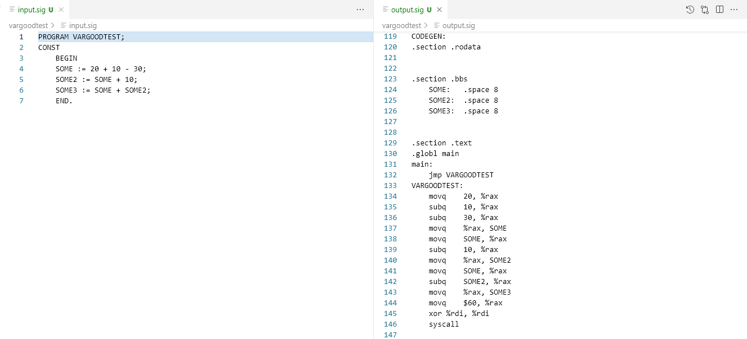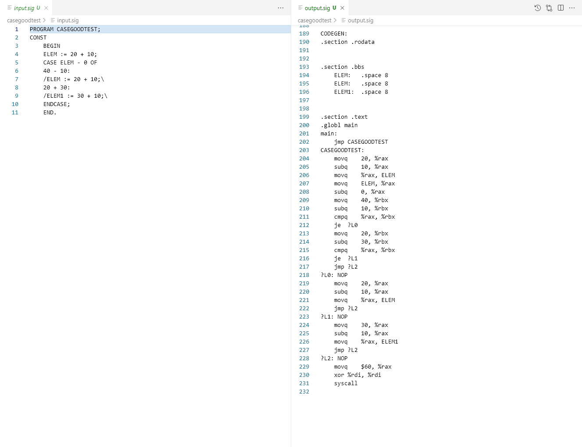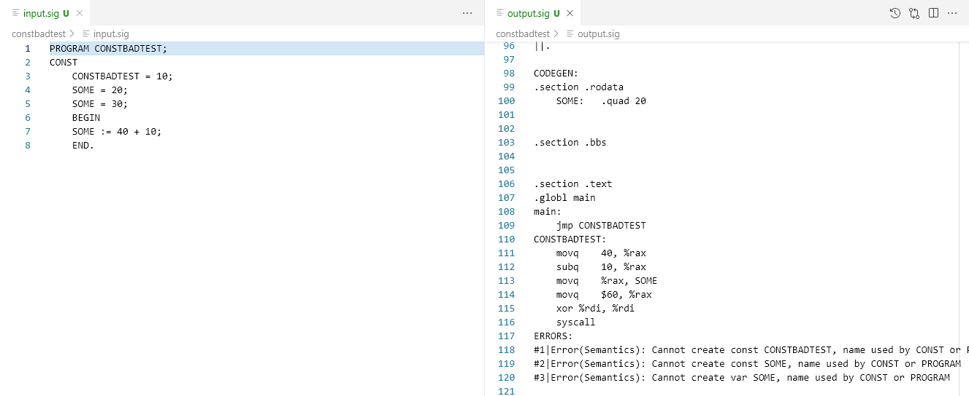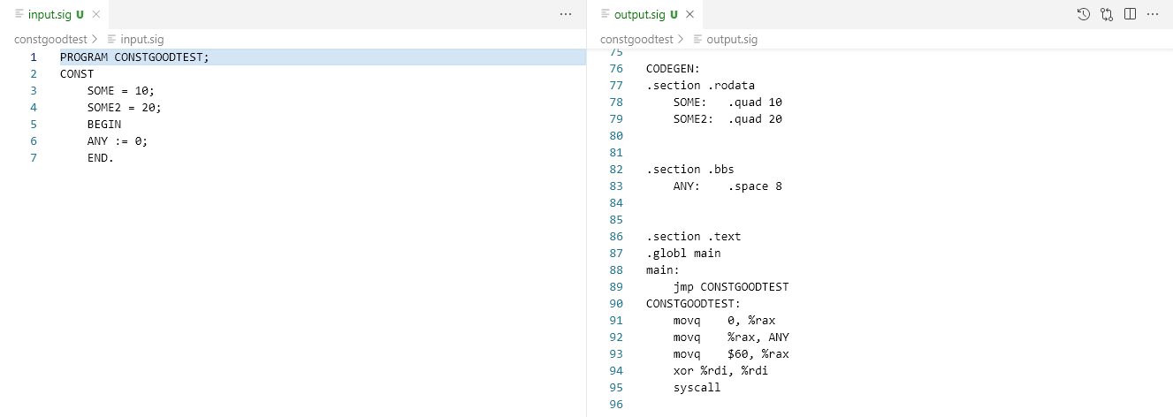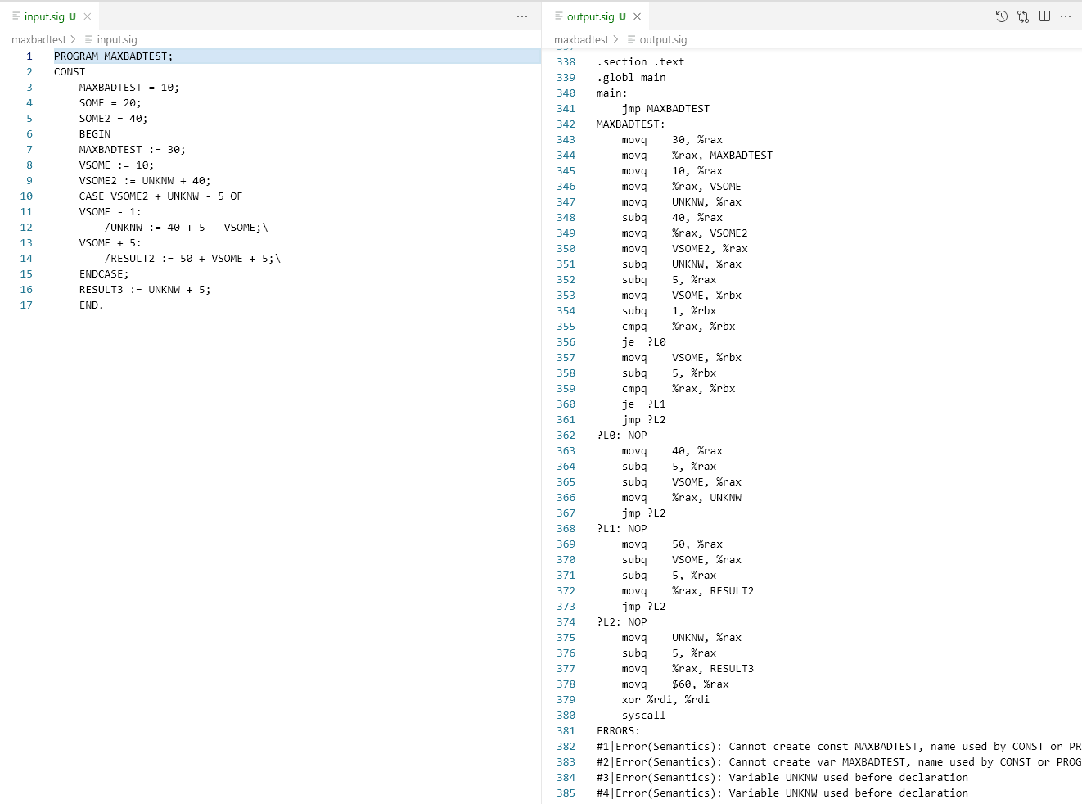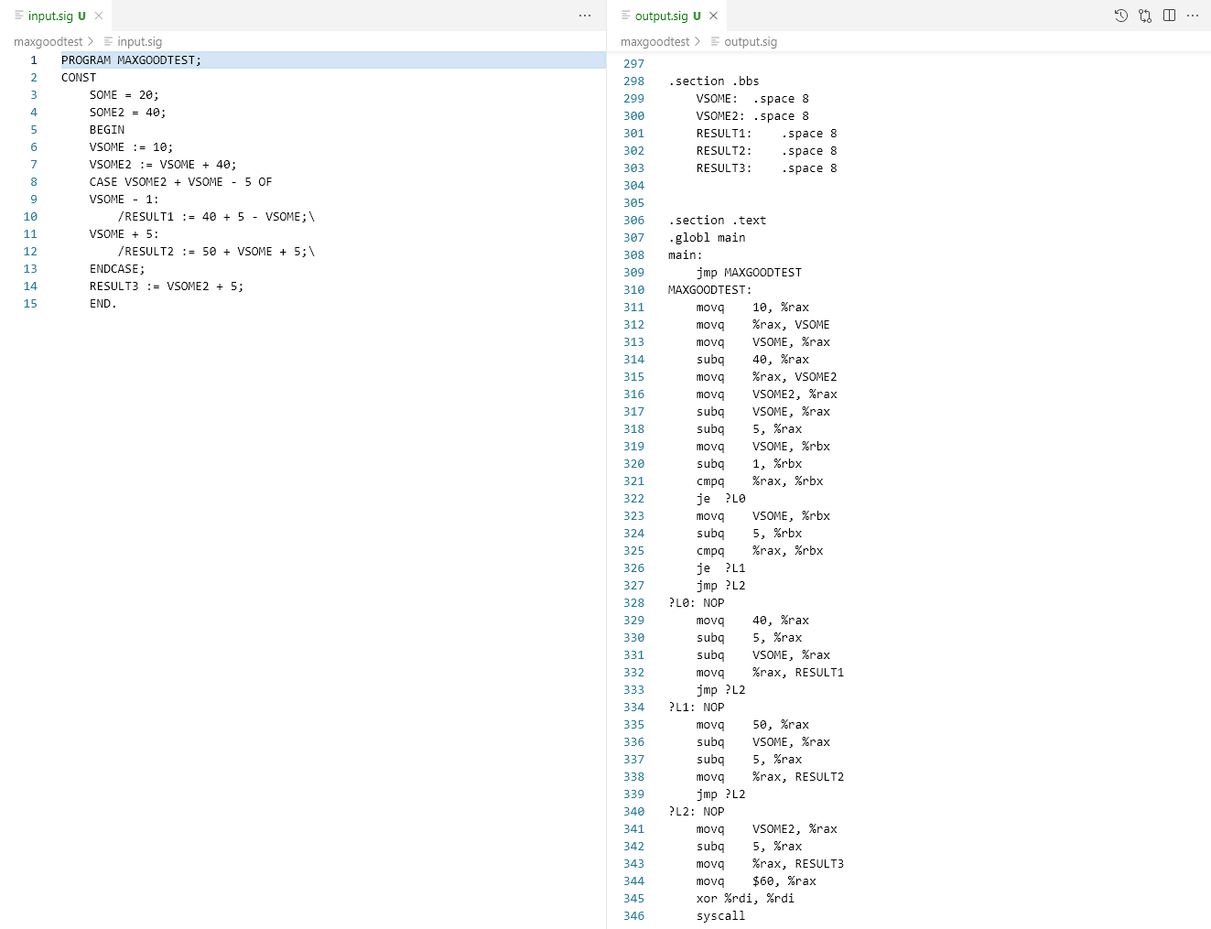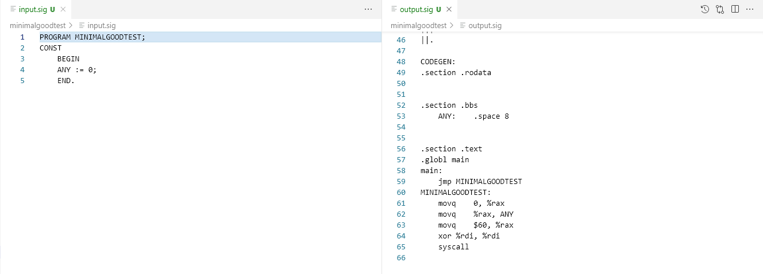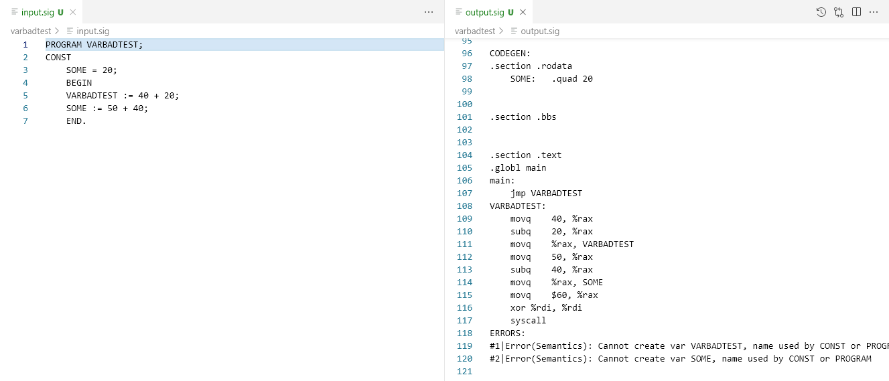

*Всі тести можна запустити з make test_semant*